# **City of Bradford Metropolitan District Council**

## **Equality Impact Assessments for the Council budget saving proposals 2025-26 contained in the report to Council Executive dated 3 December 2024 and updated following consultation feedback 12 February 2025**

**Proposal** - Street Scene commercial opportunity - £0.240 - link to equality impact assessment.

**Awaiting update**

**Proposal** - Spending Panel Outputs - £1m - link to equality impact assessment.

**No change**

**Proposal** - Fees and Charges- £2m - link to equality impact assessment.

**Updated**

* Children’s traded services - link to equality impact assessment

**New content**

* Information advice and independent careers guidance service to schools - Link to equality impact assessment

**New content**

**Proposal** - Third Party Spend - £1.5m - link to equality impact assessment.

**Updated**

**Proposal** - Enabling Efficiencies with Digital Technology – link to equality impact assessment.

**Updated**

**Proposal** - Safe and Sound Service - £0.6m - link to equality impact assessment.

**No change**

**Proposal** - Review of the Capital Programme - Revenue savings £2.600m - - link to response to consultation feedback - **New content**

**Return to contents page**

## **Equality Impact Assessment Form**

|  |  |  |  |
| --- | --- | --- | --- |
| **Department** | Place – Waste Services | **Version no** | 0.3 |
| **Assessed by** | Richard Galthen | **Date created** | 09/08/2024 |
| **Approved by** | Sue Spink | **Date approved** |  |
| **Updated by** | Richard Galthen | **Date updated** | 05/11/2024 |
| **Final approval** |  | **Date signed off** |  |

The Equality Act 2010 requires the Council to have **due regard** to the need to

* eliminate unlawful discrimination, harassment and victimisation;
* advance equality of opportunity between different groups; and
* foster good relations between different groups

**Section 1: What is being assessed?**

**1.1 Name of proposal to be assessed.**

Street Cleansing and Parks Service Review of all Commercial Operations Fees and Charges

**1.2 Describe the proposal under assessment and what change it would result in if implemented.**

This business case focuses on the following commercial services and recommends:

• **Grounds maintenance for businesses** –

*It is recommended that the Council ceases to deliver these services and focuses its full attention on delivering improvements to the core statutory duties in relation to street cleansing and parks.*

• **Bowling Green maintenance and lease.-**

*The Council undertakes a full review of existing lease agreements specifically focusing on terms and conditions in relation to repairs, maintenance and utility charges.*

• **Football/rugby pitch/changing facility maintenance and lease.**

*It is recommended the Council explores the opportunity for the local Football Association to administrate and manage leases and maintenance to clubs and:*

*The Council undertakes a full review of existing lease agreements specifically focusing on terms and conditions in relation to repairs, maintenance and utility charges.*

• **Land and Lodge rental – park and cemetery-based properties**

*A full review is undertaken of the current lodges, rental rates, and lease arrangements, including lease lengths, to ensure they reflect market conditions and align with the Council's broader asset disposal strategy.*

• **Land lease – funfairs, circus and commercial events**

*A review of the fee structures - for commercial events only - is undertaken.*

Where commercial activities cannot break even, the service may need to consider ceasing them or consider altering existing lease arrangements and fee structures to ensure financial sustainability.

**1.3 Stage 1 Assessment:**

In order to assess whether this proposal requires a full EqIA, a stage 1 assessment must be completed on all proposals. Once complete, please inform the EqIA with the outcome explaining how it was reached and who was consulted. Please also state if the need for an EqIA may be revisited, and if so under what circumstances.

|  |  |
| --- | --- |
| **Protected Characteristics:** | **Impact**  Y/N |
| Age | Y |
| Disability | Y |
| Gender reassignment | N |
| Race | N |
| Religion/Belief | N |
| Pregnancy and maternity | N |
| Sexual Orientation | N |
| Sex | N |
| Marriage and civil partnership | N |
| **Additional Consideration:** |  |
| Low income/low wage | Y |
| Care Leavers | N |

**Stage 2: Full Equality Impact Assessment:**

* 1. **Will this proposal advance equality of opportunity for people who share a protected characteristic and/or foster good relations between people who share a protected characteristic and those that do not? If yes, please explain further. Please ensure you have understood the meaning of ‘equality of opportunity’ and ‘fostering of good relations’ and ‘protected characteristics’- before answering this part.**

No

* 1. **Will this proposal have a positive impact and help to eliminate discrimination and harassment against, or the victimisation of people who share a protected characteristic? If yes, please explain further.**

No

* 1. **Will this proposal potentially have a negative and/or disproportionate impact on people who share a protected characteristic? If yes, please explain further.**

No

* 1. **Please indicate the level of negative impact on each of the protected characteristics?**

(Please indicate high (H), medium (M), low (L), no effect (N) for each)

|  |  |
| --- | --- |
| **Protected Characteristics:** | **Impact**  (H, M, L, N) |
| Age | M |
| Disability | L |
| Gender reassignment | N |
| Race | N |
| Religion/Belief | N |
| Pregnancy and maternity | N |
| Sexual Orientation | N |
| Sex | N |
| Marriage and civil partnership | N |
| **Additional Consideration:** |  |
| Low income/low wage | M |
| Care Leavers | N |

**2.5 How could the disproportionate negative impacts be mitigated or eliminated?**

*Disproportionate negative impacts potentially for elderly (in relation to bowling greens) and customers with low income. However, our charges are not usually made directly to club members or a business’s customers etc.*

**Section 3: Dependencies from other proposals**

**3.1 Please consider which other services would need to know about your proposal and the impacts you have identified. Identify below which services you have consulted, and any consequent additional equality impacts that have been identified.**

*Estates – in relation to parks-based properties/lodges that are rented to tenants across the district.*

**Section 4: What evidence have you used?**

**4.1 What evidence do you hold to back up this assessment?**

*Data analysis shows that the current pricing system, budget and service structure has not been adequate for many years in relation to Street Cleansing and Parks provision. This has caused a budget pressure and also operational pressure on statutory work which directly affects residents.*

**4.2 Do you need further evidence?**

*Yes – continuous monitoring of data including collections, tonnages, income etc.*

**Section 5: Consultation Feedback**

**5.1 Results from any previous consultations prior to the proposal development.**

*N/A*

**5.2 The departmental feedback you provided on the previous consultation (as at 5.1).**

*N/A*

**5.3 Feedback from current consultation following the proposal development (e.g. following approval by Executive for budget consultation).**

Concern expressed about possible increase in crime and  attacks on women due to reduced lighting.

**5.4 Your departmental response to the feedback on the current consultation (as at 5.3) – include any changes made to the proposal as a result of the feedback.**

**Awaiting update**

**Return to contents page**

**Return to contents page**

## **Equality Impact Assessment Form**

|  |  |  |  |
| --- | --- | --- | --- |
| **Department** | Corporate Resources | **Version no** | V0.01 |
| **Assessed by** | Helen Johnston | **Date created** | 05/11/2024 |
| **Approved by** |  | **Date approved** |  |
| **Updated by** |  | **Date updated** |  |
| **Final approval** |  | **Date signed off** |  |

Please keep a record of when updates are made and who has made them. Final approval should be given before the EqIA is published. A referencing system will be in place for annual budget changes, but outside of this, you should use your service’s own reference. The reference should remain the same from initial proposal through to implementation and ongoing reviews. Please remember that a full EqIA ONLY needs completing if you have decided there are impacts (positive or negative) on people at **stage 1** of the EqIA process. If there are no impacts then this should be recorded both on the EqIA and in a publicly available format (e.g. a committee report) **with a summary of why you have reached this conclusion.**

The Equality Act 2010 requires the Council to have **due regard** to the need to

* eliminate unlawful discrimination, harassment and victimisation;
* advance equality of opportunity between different groups; and
* foster good relations between different groups

**Section 1: What is being assessed?**

**1.1 Name of proposal to be assessed.**

Spending Control Panels – outputs

**1.2 Describe the proposal under assessment and what change it would result in if implemented.**

Spending Panels provide a process to support the effective and efficient use of funds. They bring a consistency to General Fund spending decisions across the Council.

The proposal is to apply a percentage reduction in spend across the board to generate £1m per annum.

Applications submitted for Spending Panels’ consideration are supported by an EQIA where required.

**1.3 Stage 1 Assessment:**

In order to assess whether this proposal requires a full EqIA, a stage 1 assessment must be completed on all proposals. Once complete, please inform the EqIA with the outcome explaining how it was reached and who was consulted. Please also state if the need for an EqIA may be revisited, and if so under what circumstances.

|  |  |
| --- | --- |
| **Protected Characteristics:** | **Impact**  Y/N |
| Age | N |
| Disability | N |
| Gender reassignment | N |
| Race | N |
| Religion/Belief | N |
| Pregnancy and maternity | N |
| Sexual Orientation | N |
| Sex | N |
| Marriage and civil partnership | N |
| **Additional Consideration:** |  |
| Low income/low wage | N |
| Care Leavers | N |

**Return to contents page**

**Return to contents page**

## **Equality Impact Assessment Form**

|  |  |  |  |
| --- | --- | --- | --- |
| **Department** | Corporate Resources | **Version no** | V0.1 |
| **Assessed by** | Andrew Cross | **Date created** | 14/11/2024 |
| **Approved by** |  | **Date approved** |  |
| **Updated by** |  | **Date updated** |  |
| **Final approval** |  | **Date signed off** |  |

Please keep a record of when updates are made and who has made them. Final approval should be given before the EqIA is published. A referencing system will be in place for annual budget changes, but outside of this, you should use your service’s own reference. The reference should remain the same from initial proposal through to implementation and ongoing reviews. Please remember that a full EqIA ONLY needs completing if you have decided there are impacts (positive or negative) on people at **stage 1** of the EqIA process. If there are no impacts then this should be recorded both on the EqIA and in a publicly available format (e.g. a committee report) **with a summary of why you have reached this conclusion.**

The Equality Act 2010 requires the Council to have **due regard** to the need to

* eliminate unlawful discrimination, harassment and victimisation;
* advance equality of opportunity between different groups; and
* foster good relations between different groups

**Section 1: What is being assessed?**

**1.1 Name of proposal to be assessed.**

Increase income through a six percent increase in sales, fees, and charges across a wide range of chargeable services.

**1.2 Describe the proposal under assessment and what change it would result in if implemented.**

The cost of Council services increases each year because of pay awards and inflationary pressures, and consequently the Council increases sales, fees and charges each year to help contribute towards these.

Many of the services generating larger amounts of sales, fees and charges are also those that typically have lower graded staff that have been receiving pay awards in excess of the general level of inflation (CPI).

Consequently, the cost base of those services is also disproportionately impacted. To help fund those increases and make a small contribution to the Council returning to a financially sustainable position, a 6% increase in budgets is proposed.

To help deliver this 6% increase, a default 6% increase in prices is also proposed with deviations where rates are set by Government or where Council services have provided a justification for a different rate.

The proposal intends to raise an additional £5.4m of income in 2025-26

**1.3 Stage 1 Assessment:**

In order to assess whether this proposal requires a full EqIA, a stage 1 assessment must be completed on all proposals. Once complete, please inform the EqIA with the outcome explaining how it was reached and who was consulted. Please also state if the need for an EqIA may be revisited, and if so under what circumstances.

|  |  |
| --- | --- |
| **Protected Characteristics:** | **Impact**  Y/N |
| Age | Y |
| Disability | Y |
| Gender reassignment | N |
| Race | N |
| Religion/Belief | N |
| Pregnancy and maternity | N |
| Sexual Orientation | N |
| Sex | N |
| Marriage and civil partnership | N |
| **Additional Consideration:** |  |
| Low income/low wage | Y |
| Care Leavers | N |

**Stage 2: Full Equality Impact Assessment:**

The full impact assessment process outlined below, will examine what the impact of the proposal is likely to be on protected groups, low income groups and care leavers.

The Equality Act 2010 requires that we give due regard to **advancing equality of opportunity and fostering good relations**. Will your proposal support either of these two aims? It is particularly important that positive impacts are highlighted when they affect a lot of people or have high impact on a small number of people.

* 1. **Will this proposal advance equality of opportunity for people who share a protected characteristic and/or foster good relations between people who share a protected characteristic and those that do not? If yes, please explain further. Please ensure you have understood the meaning of ‘equality of opportunity’ and ‘fostering of good relations’ and ‘protected characteristics’- before answering this part.**

No

* 1. **Will this proposal have a positive impact and help to eliminate discrimination and harassment against, or the victimisation of people who share a protected characteristic? If yes, please explain further.**

No

* 1. **Will this proposal potentially have a negative and/or disproportionate impact on people who share a protected characteristic? If yes, please explain further.**

Although the proposed 6% increase in sales, fees and charges is in line with the increased cost of providing the chargeable services in scope, some protected groups may be more impacted than others, as, for instance, these chargeable services may:

* be necessary to support daily living
* be accessed to build and maintain social and community connections
* cost more proportionally due to income level

Disproportionate impacts may be experienced by older and younger people, those with disabilities and those on low incomes.

* 1. **Please indicate the level of negative impact on each of the protected characteristics?**

Proportionality needs applying when considering the level of the impact. A change in social care provision is likely to have much higher impact than reducing grass cutting, even though both could have impacts.

(Please indicate high (H), medium (M), low (L), no effect (N) for each)

|  |  |
| --- | --- |
| **Protected Characteristics:** | **Impact**  (H, M, L, N) |
| Age | M |
| Disability | M |
| Gender reassignment | N |
| Race | N |
| Religion/Belief | N |
| Pregnancy and maternity | N |
| Sexual Orientation | N |
| Sex | N |
| Marriage and civil partnership | N |
| **Additional Consideration:** |  |
| Low income/low wage | M |
| Care Leavers | N |

**2.5 How could the disproportionate negative impacts be mitigated or eliminated?**

*(Note: Legislation and best practice require mitigations to be considered) Please state what mitigations are to be brought into place for any group scoring a medium and above. If no mitigations are being considered, the reasons for this should also be included here).*

This assessment does not assess the impacts of the increase in sales, fees, charges for chargeable services provided by each department.

Assessments are being undertaken across the range of chargeable services, with possible mitigations identified where it is found there is a disproportionate impact on a protected characteristic(s)

These departments provide chargeable services:

* Corporate Resources
* Children’s Services
* Adult Services
* Place
* Office of the Chief Executive

**Section 3: Dependencies from other proposals**

**3.1 Please consider which other services would need to know about your proposal and the impacts you have identified. Identify below which services you have consulted, and any consequent additional equality impacts that have been identified.**

All departments are involved in this proposal and are working with their services and the corporate centre to undertake granular equality impact assessments against chargeable services, and to contribute to the production of a cumulative equality impact assessment against this proposal that will also be used to inform the Council’s overall budget saving proposals cumulative equality impact assessment.

**Section 4: What evidence have you used?**

**4.1 What evidence do you hold to back up this assessment?**

Please identify any evidence you have that supports your assessment. Key points need to be listed here. If the evidence is outlined in a large document, this should be referenced (from a public location) with a link but key points must still be highlighted.

[Intelligence Bulletin 30 July 2024 – A profile of Bradford District 2024](https://ubd.bradford.gov.uk/media/1851/bradford-district-profile-2024.pdf)

[Demographics of Bradford District – JSNA](https://jsna.bradford.gov.uk/media/52sbbext/jsna-demographic-resource-pack-2024.pdf)

Information about individual fees and charges.

**4.2 Do you need further evidence?**

Departmental equality impact assessments against their chargeable services are required.

**Section 5: Consultation Feedback**

**5.1 Results from any previous consultations prior to the proposal development.**

Specific fees and charges increases were proposed and approved in 2024-25. Any consultation feedback received about these is contained in this document:

[**Council revenue estimates 2024-25 and consultation feedback**](https://bradford.moderngov.co.uk/documents/s46351/Doc%20AL%20-%20Revenue%20Estimates.pdf)

**5.2 The departmental feedback you provided on the previous consultation (as at 5.1).**

The response to any feedback received in the previous year is contained in this document:

[Resolutions of Executive Committee 5 March 2024](https://bradford.moderngov.co.uk/mgAi.aspx?ID=21798)

**5.3 Feedback from current consultation following the proposal development (e.g. following approval by Executive for budget consultation).**

Will impact those on low income, as unaffordable.

**5.4 Your departmental response to the feedback on the current consultation (as at 5.3) – include any changes made to the proposal as a result of the feedback.**

Equality Impact Assessments are being undertaken within departments against fees and charges for their services and will be published.

The Council does already take mitigating action against some fees and charges, for example the Bradford Leisure Card that provides reduced admission to a range of leisure activities for those who qualify – such as for instance those over 60 years-old, full time students, people receiving specific allowances or benefits. More information is available at: <https://www.bradford.gov.uk/sport-and-activities/membership-and-prices/bradford-leisure-card/>

**Return to contents page**

The following are two department specific Fees and Charges equality impact assessments for Children’s traded services and OCX’s Information advice and independent careers guidance service to schools.

**Return to contents page**

Equality Impact Assessment Form **Reference –**

|  |  |  |  |
| --- | --- | --- | --- |
| **Department** | Children’s Services | **Version no** | 1 |
| **Assessed by** | Adèle Rowley | **Date created** | 19/11/24 |
| **Approved by** |  | **Date approved** |  |
| **Updated by** | Adèle Rowley | **Date updated** | 21/11/24 |
| **Final approval** |  | **Date signed off** |  |

The Equality Act 2010 requires the Council to have **due regard** to the need to

* eliminate unlawful discrimination, harassment and victimisation;
* advance equality of opportunity between different groups; and
* foster good relations between different groups

# Section 1: What is being assessed?

**1.1 Name of proposal to be assessed.**

Corporate-wide increase on all traded services fees and charges. This assessment

relates to traded services within Children’s Services.

**1.2 Describe the proposal under assessment and what change it would result in if implemented.**

The Council has well documented financial challenges and needs to improve its financial position by reducing costs and increasing income where possible.

Sales, fees and charges are key sources of income. There is a significant amount of regulation that governs sales, fees and charges, and in all cases the Council must ensure compliance with legislation.

In some instances, charge rates are directly set by Government, but in others the Council has powers to set prices as long as it remains compliant with the regulations, and it is economic to do so in line with market conditions.

In addition to the financial challenges, the Council’s cost base also increases each year in line in inflationary pressures. This includes for example staff pay awards that are budgeted at 4% for 2025-26, with lower paid staff typically receiving higher % increases in pay than senior staff, and many of the services that generate high levels of fees and charges, are those with typically higher proportions of lower paid staff.

A default 6% target increase in in-scope sales, fees and charges income budgets for 2025-26 is proposed which would raise c£4.8m.

**1.3 Stage 1 Assessment:**

|  |  |  |  |  |  |  |  |  |  |  |
| --- | --- | --- | --- | --- | --- | --- | --- | --- | --- | --- |
| **Protected Characteristics / Impact (Y/N)** | **Admissions (RP)** | **Attendance / Education Safeguarding (KH)** | **Education Psychology (CCJ)** | **Interfaith (AR)** | **Outdoor Ed (SS)** | **Play (AR)** | **Music & Arts (CW)** | **School Governors (AR)** | **School Improvement (MW)** | **SEN (AN/**  **TA)** |
| Age | N | N | N | N | N | N | Y | N | N | N |
| Disability | N | N | N | N | Y | N | Y | N | N | N |
| Gender reassignment | N | N | N | N | N | N | N | N | N | N |
| Race | N | N | N | N | Y | N | N | N | N | N |
| Religion/Belief | N | N | N | N | N | N | N | N | N | N |
| Pregnancy and maternity | N | N | N | N | N | N | N | N | N | N |
| Sexual Orientation | N | N | N | N | N | N | N | N | N | N |
| Sex | N | N | N | N | N | N | N | N | N | N |
| Marriage and civil partnership | N | N | N | N | N | N | N | N | N | N |
| **Additional Consideration:** |  |  |  |  |  |  |  |  |  |  |
| Low income/low wage | N | N | N | N | Y | N | Y | N | N | N |
| Care Leavers | N | N | N | N | Y | N | N | N | N | N |

The following teams are the only ones who work directly with children and young people, the rest are commissioned by schools so the impact would only come if the schools decided to no longer commission the service at all rather than sourcing it elsewhere:

* Outdoor Education Centre
* Music & Arts

# Stage 2: Full Equality Impact Assessment **(only for those services outlined where the change will have an impact on the protected characteristic groups):**

The Equality Act 2010 requires that we give due regard to **advancing equality of opportunity and fostering good relations**. Will your proposal support either of these two aims? It is particularly important that positive impacts are highlighted when they affect a lot of people or have high impact on a small number of people.

* 1. **Will this proposal advance equality of opportunity for people who share a protected characteristic and/or foster good relations between people who share a protected characteristic and those that do not? If yes, please explain further. Please ensure you have understood the meaning of ‘equality of opportunity’ and ‘fostering of good relations’ and ‘protected characteristics’- before answering this part.**

No it will not have an impact in this way.

* 1. **Will this proposal have a positive impact and help to eliminate discrimination and harassment against, or the victimisation of people who share a protected characteristic? If yes, please explain further.**

No it will not have an impact in this way.

* 1. **Will this proposal potentially have a negative and/or disproportionate impact on people who share a protected characteristic? If yes, please explain further.**

**Music & Arts** - Yes, increase in fees for access to instrumental lessons will cause additional barriers to those on low or limited incomes.

**Outdoor Education Centre** - The opportunity for children and young people to access outdoor education and associated activities is not possible for a lot of children. Working with schools we provide the outdoor experience that benefits the physical and mental health and wellbeing of children from high deprivation areas.  The increased costs for the service have to be covered by the school with many seeking contributions from their parents.   Given the financial pressures on schools and cost of living on parents, there is a risk that continued price increases may result in reduced take up.

This EQIA will be under continual review as more information becomes available.

* 1. **Please indicate the level of negative impact on each of the protected characteristics?**

(Please indicate high (H), medium (M), low (L), no effect (N) for each)

|  |  |  |  |  |  |  |  |  |  |  |
| --- | --- | --- | --- | --- | --- | --- | --- | --- | --- | --- |
| **Protected Characteristics / Impact**  **(H, M, L, N)** | **Admissions (RP)** | **Attendance / Education Safeguarding (KH)** | **Education Psychology (CCJ)** | **Interfaith (AR)** | **Outdoor Ed (SS)** | **Play (AR)** | **Music & Arts (CW)** | **School Governors (AR)** | **School Improvement (MW)** | **SEN (AG/TA)** |
| Age | N | N | N | N | N | N | L | N | N | N |
| Disability | N | N | N | N | M | N | L | N | N | N |
| Gender reassignment | N | N | N | N | N | N | N | N | N | N |
| Race | N | N | N | N | M | N | N | N | N | N |
| Religion/Belief | N | N | N | N | N | N | N | N | N | N |
| Pregnancy and maternity | N | N | N | N | N | N | N | N | N | N |
| Sexual Orientation | N | N | N | N | N | N | N | N | N | N |
| Sex | N | N | N | N | N | N | N | N | N | N |
| Marriage and civil partnership | N | N | N | N | N | N | N | N | N | N |
| **Additional Consideration:** |  |  |  | N | N | N | N | N |  |  |
| Low income/low wage | N | N | N | N | M | N | H | N | N | N |
| Care Leavers | N | N | N | N | M | N | N | N | N | N |

**2.5** **How could the disproportionate negative impacts be mitigated or eliminated?**

**Music & Arts** - The service has a robust remissions policy to support those on low incomes, including accessing pupil premium support and external funding from ACE and Young Sounds UK.

**Outdoor Education Centre** - We are expanding our offer to corporate organisations, families, walking groups, cycling groups etc. To increase revenue outside term time and at weekends. In the long term the aim is to enable us to offer reduced pricing for Bradford schools.

# Section 3: Dependencies from other proposals

**3.1 Please consider which other services would need to know about your proposal and the impacts you have identified. Identify below which services you have consulted, and any consequent additional equality impacts that have been identified.**

Schools and other clients would need to be informed of the fee increases in order to assess the impact on their own service.

# Section 4: What evidence have you used?

**4.1 What evidence do you hold to back up this assessment?**

**Music & Arts** - Annual data survey submission to ACE and DfE.

**Outdoor Education Centre** - Deprivation data for the district including number of FSM and Pupil Premium distribution. Feedback from children, schools, short breaks and fostering teams

**4.2 Do you need further evidence?**

We are continually assessing information from each service to assess the potential impact of any fee increases on children and young people.

# Section 5: Consultation Feedback

**5.1 Results from any previous consultations prior to the proposal development.**

No consultations have taken place.

**5.2 The departmental feedback you provided on the previous consultation (as at 5.1).**

Not applicable.

**5.3 Feedback from current consultation following the proposal development (e.g. following approval by Executive for budget consultation).**

Not applicable.

**5.4 Your departmental response to the feedback on the current consultation (as at 5.3) – include any changes made to the proposal as a result of the feedback.**

Services will respond to any feedback they receive on potential impact of this proposal.

**Return to contents page**

**Return to contents page**

Equality Impact Assessment Form **Reference –**

|  |  |  |  |
| --- | --- | --- | --- |
| **Department** | Employment and Skills | **Version no** |  |
| **Assessed by** | Alexandra Willans | **Date created** | 21.11.24 |
| **Approved by** |  | **Date approved** |  |
| **Updated by** |  | **Date updated** |  |
| **Final approval** |  | **Date signed off** |  |

Please keep a record of when updates are made and who has made them. Final approval should be given before the EqIA is published. A referencing system will be in place for annual budget changes, but outside of this, you should use your service’s own reference. The reference should remain the same from initial proposal through to implementation and on going reviews. Please remember that a full EqIA ONLY needs completing if you have decided there are impacts (positive or negative) on people at **stage 1** of the EqIA process.. If there are no impacts then this should be recorded both on the EqIA and in a publicly available format (e.g. a committee report) **with a summary of why you have reached this conclusion.**

The Equality Act 2010 requires the Council to have **due regard** to the need to

* eliminate unlawful discrimination, harassment and victimisation;
* advance equality of opportunity between different groups; and
* foster good relations between different groups

# Section 1: What is being assessed?

* 1. **Name of proposal to be assessed.**

Increase income generated in sales and charges for providing an Information advice and independent careers guidance service to schools by 6%.

**1.2 Describe the proposal under assessment and what change it would result in if implemented.**

Council increases service costs year on year, due to pay awards and inflation. The proposal for 2025/2026 proposes an increase of 6%. This charge is acknowledged by service and expected for 2025/2026. The new charge will start in Sept 2025.

Bradford and out of area schools both access this service as such two price points are reflected.

There are no wider mitigations known to refute the proposed 6% increase. The service is provided for schools; duties and responsibilities are with the school to source independent career guidance and do not lie with the local authority. Any impact lies with the school.

This service provision also enables us to better meet our duties and responsibilities as a council with respect to the following.

* Education and Skills Act 2008 to raise the age of participation to 18 years of age and promoting the participation of their activity and associated tracking and monitoring
  + Early intervention – our NEET strategy.
  + Post 16 transitions
* Lead the September Guarantee process for 16 year olds.

**1.3 Stage 1 Assessment:**

In order to assess whether this proposal requires a full EqIA, a stage 1 assessment must be completed on all proposals. Once complete, please inform the EqIA with the outcome explaining how it was reached and who was consulted. Please also state if the need for an EqIA may be revisited, and if so under what circumstances.

|  |  |
| --- | --- |
| **Protected Characteristics:** | **Impact**  Y/N |
| Age | N |
| Disability | N |
| Gender reassignment | N |
| Race | N |
| Religion/Belief | N |
| Pregnancy and maternity | N |
| Sexual Orientation | N |
| Sex | N |
| Marriage and civil partnership | N |
| **Additional Consideration:** |  |
| Low income/low wage | N |
| Care Leavers | N |

# **Stage 2: Full Equality Impact Assessment:**

# **The full impact assessment process outlined below, will examine what the impact of the proposal is likely to be on protected groups, low income groups and care leavers.**

The Equality Act 2010 requires that we give due regard to **advancing equality of opportunity and fostering good relations**. Will your proposal support either of these two aims? It is particularly important that positive impacts are highlighted when they affect a lot of people or have high impact on a small number of people.

* 1. **Will this proposal advance equality of opportunity for people who share a protected characteristic and/or foster good relations between people who share a protected characteristic and those that do not? If yes, please explain further. Please ensure you have understood the meaning of ‘equality of opportunity’ and ‘fostering of good relations’ and ‘protected characteristics’- before answering this part.**
  2. **Will this proposal have a positive impact and help to eliminate discrimination and harassment against, or the victimisation of people who share a protected characteristic? If yes, please explain further.**

The Equality Act 2010 requires that we give due regard to eliminating discrimination, harassment and victimisation. Will your proposal support this aim? It is particularly important that negative and positive impacts are highlighted when they affect a lot of people or have high impact on a small number of people.

* 1. **Will this proposal potentially have a negative and/or disproportionate impact on people who share a protected characteristic? If yes, please explain further.**

Consider all the protected characteristics, and identify which of them are likely to be

affected disproportionately. If you are unsure, then it may be useful to speak to protected groups for their views. If you do not hold this information in the initial stages, further evidence should be gathered (see sections 4 and 5). This could be impacts on direct users of the service now or in the future, or people associated with them (e.g. family members, carers).

Due regard must be given where there is an identified high disproportionate impact on a group of people – however legislation will be contravened if consideration (due

regard) is not given and evidenced. Other minimum statutory duties must also be

met such as not discriminating (as outlined in the Equality Act 2010), and any other

legislation that my relate to your proposal and area of work.

* 1. **Please indicate the level of negative impact on each of the protected characteristics?**

Proportionality needs applying when considering the level of the impact. A change in social care provision is likely to have much higher impact than reducing grass cutting, even though both could have impacts.

(Please indicate high (H), medium (M), low (L), no effect (N) for each)

|  |  |
| --- | --- |
| **Protected Characteristics:** | **Impact**  (H, M, L, N) |
| Age |  |
| Disability |  |
| Gender reassignment |  |
| Race |  |
| Religion/Belief |  |
| Pregnancy and maternity |  |
| Sexual Orientation |  |
| Sex |  |
| Marriage and civil partnership |  |
| **Additional Consideration:** |  |
| Low income/low wage |  |
| Care Leavers |  |

**2.5 How could the disproportionate negative impacts be mitigated or eliminated?**

(Note: Legislation and best practice require mitigations to be considered) Please state what mitigations are to be brought into place for any group scoring a medium and above. If no mitigations are being considered, the reasons for this should also be included here.

# Section 3: Dependencies from other proposals

**3.1 Please consider which other services would need to know about your proposal and the impacts you have identified. Identify below which services you have consulted, and any consequent additional equality impacts that have been identified.**

Cumulative impacts are likely when many changes are being made across the Council. Ensure you liaise with colleagues within your own service and other departments to assess whether your changes will have knock-on impacts on their customers or vice versa. Also it may be important to consider impacts from partner organisations making changes to their services.

# Section 4: What evidence have you used?

**4.1 What evidence do you hold to back up this assessment?**

Please identify any evidence you have that supports your assessment. Key points need to be listed here. If the evidence is outlined in a large document, this should be referenced (from a public location) with a link but key points must still be highlighted.

**4.2 Do you need further evidence?**

In the early stages you may not hold all the evidence you need to undertake a detailed assessment. Identify gaps, and ensure work is put in place to fill those gaps – this could be through a desktop exercise or consultation (see section 5). As that evidence is collated update the relevant sections accordingly with a new version number.

# Section 5: Consultation Feedback

**5.1 Results from any previous consultations prior to the proposal development.**

Consultations may have been undertaken in recent years that impact on this proposal. These should be considered and presented here – provide links to existing public documentation and a summary of key points. Please ensure all previous information is relevant and current to the proposal being considered.

**5.2 The departmental feedback you provided on the previous consultation (as at 5.1).**

At the time of the consultation identified in 5.1, your department may have provided feedback or made some changes as a consequence of the results of the consultation. Those considerations should be listed here, or if listed in other public documents a link and a summary provided.

**5.3 Feedback from current consultation following the proposal development (e.g. following approval by Executive for budget consultation).**

**5.4 Your departmental response to the feedback on the current consultation (as at 5.3) – include any changes made to the proposal as a result of the feedback.**

**Return to contents page**

**Return to contents page**

## **Equality Impact Assessment Form**

|  |  |  |  |
| --- | --- | --- | --- |
| **Department** | CORPORATE RESOURCES | **Version no** |  |
| **Assessed by** |  | **Date created** | 10 Sept 2024 |
| **Approved by** |  | **Date approved** |  |
| **Updated by** |  | **Date updated** |  |
| **Final approval** |  | **Date signed off** |  |

**Section 1: What is being assessed?**

* 1. This pertains to a Business Case designed to deliver £2m in savings in 25 / 26 via a Programme underpinned by five procurement-related projects. These are detailed in the table below:

|  |  |  |
| --- | --- | --- |
| Savings Strategy | Title | Savings Value (£.m) |
| Re-procure a case management system for both Adult and Children’s social care | Project A | 0.250 |
| Re- procure Security contract and make savings on off-contract expenditure | Project B | 0.250 |
| Generate additional rebate via the increased use of Payment cards with identified suppliers | Project C | 0.600 |
| Channel all Consultancy expenditure via a Crown Commercial Services (CCS) framework to benefit from more advantageous terms | Project D | 0.700 |
| Re-procure Gas and Water supply on more advantageous terms | Project E | 0.200 |

1.2 This proposal would support the Council’s journey towards future financial sustainability and the medium-term Financial Strategy by delivering £2m in savings via the actions as detailed above. This is a key objective of the Council’s wider Transformation Programme.

**1.3 Stage 1 Assessment:**

None of the protected characteristics are impacted by this proposal. This outcome was reached by the Head of Procurement who prepared the business case and is being presented to the Subject Matter Expert (Khalida Ashrafi) for quality assurance and validation. The intention is to keep this Stage One assessment under continual review in case any of the protected characteristics should become impacted. This is deemed unlikely given the clear-cut nature of the business case.

This decision, and the rationale behind it, will be made available in public documentation when the consultation process with Elected Members has concluded and the business cases become available for general access with commercial sensitivities redacted.

|  |  |
| --- | --- |
| **Protected Characteristics:** | **Impact**  Y/N |
| Age | N |
| Disability | N |
| Gender reassignment | N |
| Race | N |
| Religion/Belief | N |
| Pregnancy and maternity | N |
| Sexual Orientation | N |
| Sex | N |
| Marriage and civil partnership | N |
| **Additional Consideration:** |  |
| Low income/low wage | N |
| Care Leavers | N |

**Feedback from Council budget engagement and consultation**

The consultation is not designed for those who will be more impacted by the proposals – such as from BME communities or people with additional needs

**Departmental response to this feedback**

The cumulative impact assessment undertaken across the budget proposals 2025-26 for consultation indicated that age, disability, and low income/low wage were the protected characteristics most impacted. With one high level impact identified for sex.

In addition to the online survey, additional in person focus sessions were undertaken with:

* Voluntary and Community Sector Network leads
* People with learning disabilities
* Disabled people
* Those experiencing low income/low wage
* Race Equality Network.

Separate consultation was undertaken on two of the proposals where a high impact had been identified for age and disability (Post 16 Transport Policy and Safe and Sound).

The third proposal with a high impact was Managing Street Lighting Energy. This was identified as having a high impact on age, disability and sex.

A review of the consultation process will be undertaken, with feedback taken into account as part of this review.

**Return to contents page**

**Return to contents page**

## **Equality Impact Assessment Form**

|  |  |  |  |
| --- | --- | --- | --- |
| **Department** | Transformation and change | **Version no** | V0.2 |
| **Assessed by** | Taslima Qureshi | **Date created** | 30/08/2024 |
| **Approved by** | Gemma Emmett | **Date approved** | 16/09/2024 |
| **Updated by** | Khalida Ashrafi | **Date updated** | 03/09/2024 |
| **Final approval** | Jenny Cryer | **Date signed off** | 17/09/2024 |

Please keep a record of when updates are made and who has made them. Final approval should be given before the EqIA is published. A referencing system will be in place for annual budget changes, but outside of this, you should use your service’s own reference. The reference should remain the same from initial proposal through to implementation and ongoing reviews. Please remember that a full EqIA ONLY needs completing if you have decided there are impacts (positive or negative) on people at stage 1 of the EqIA process. If there are no impacts, then this should be recorded both on the EqIA and in a publicly available format (e.g. a committee report) with a summary of why you have reached this conclusion.

The Equality Act 2010 requires the Council to have due regard to the need to

* eliminate unlawful discrimination, harassment and victimisation.
* advance equality of opportunity between different groups; and
* foster good relations between different groups

**Section 1: What is being assessed?**

**1.1 Name of proposal to be assessed.**

Overarching Digital Transformation Programme. Within this programme there are seven projects which will have individual equality impact assessments completed.

**1.2 Describe the proposal under assessment and what change it would result in if implemented.**

The overarching digital transformation programme provides an overview to rationale benefits of digital transformation in City of Bradford Metropolitan District Council (CBMDC), emphasising its potential to drive significant efficiencies and savings across the organisation in response to BBERT financial sustainability, council Improvement plan, and aligns to the district digital strategy and IT digital strategy.

The digital transformation programme is a **critical enabler** for City of Bradford Metropolitan District Council (CBMDC) to adopt a strategic approach to modernising infrastructure, automating processes, and leveraging data, to enhance operational efficiencies and improve service delivery to achieve significant cost savings, but also future-proof operations for sustained success.

The programme will take a whole-council approach to bring together digital services transformation to multiple areas within a local authority and will design to address the systemic barriers that make it challenging for the Council to sustain digital transformation and to become modern, resilient organisations.

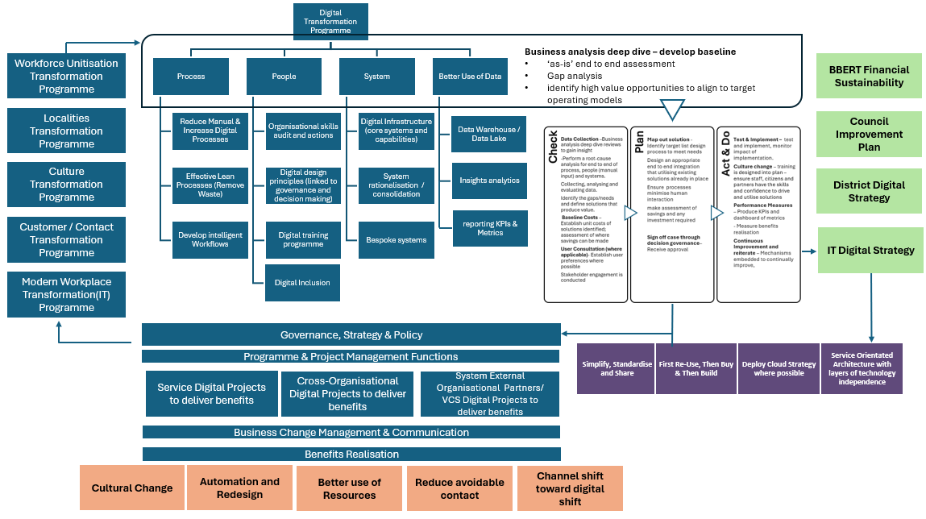

**Background and Business Need**

The programme business case will design the overarching governance structure needed to take a whole-council approach to bring together digital transformation corporately and to multiple service areas within the Council.

**A diagram where decisions will be made in the Council to support teh digital programme's implementation. 

**

The programme will enable the building blocks for key delivery areas in other transformation and change programmes:

* Application and IT Infrastructure 2024-2027 Business Case
* Workforce unitisation
* Customer contact management
* Modern workplace transformation
* Culture transformation programme
* Localities programme
* Improving our use of data (linked to the HDRC)

It is imperative to build and maintain an agile IT architecture fit for the digital age both internally facing and for citizens.

The customer contact management programme has begun the drive to improve the customer journey with the implementation of digital capability and technology such as automation (for voice contact and to streamline manual processes), optimisation of the website and webforms, and centralise resources dealing with customer contact across the organisation. This structural consolidation aims to improve customer experience by increasing efficiency and reducing duplication and hand-offs.

Similar channel shift to ‘digital first’ capabilities for staff, and as an organisation, would also improve service delivery, reduce operating costs and manage demand more effectively, ensuring the local authority workforce and IT infrastructure and architecture is agile and adaptable in the digital age.

**Vision**

To establish and implement the business capabilities necessary for the Council to become a digitally enabled organisation, optimising efficiencies in internal processes and better meeting the growing demands on services in a more cost-effective way.

This means becoming ‘digital-by-default’, which is defined as digital services that are so straightforward and convenient, that all those who can use them will choose to do so, whilst those who cannot are not excluded.

**Objectives**

The objectives for the overarching digital programme below:

* To embody a **‘digital first’** culture, which does not exclude those who cannot, and that our staff, citizens and partners have the skills and confidence to drive and utilise this
* To ensure our services are **customer-focussed**, lean and cost- effective and are easily accessible and provide resolution at the earliest opportunity.
* To ensure end to end digital enabling capabilities, that are efficient and well run which will champion a workforce culture of **high performance, high challenge** and **high support**.
* To have digital infrastructure which **prevent avoidable demand** through early help, help signpost residents to community-based assets, and supporting residents to live well.
* Take collective responsibility and ownership for the Council Strategy, prioritising cross-departmental collaboration and a **One Council** approach and have proportionate **governance in place for effective decision-making** to achieve this.

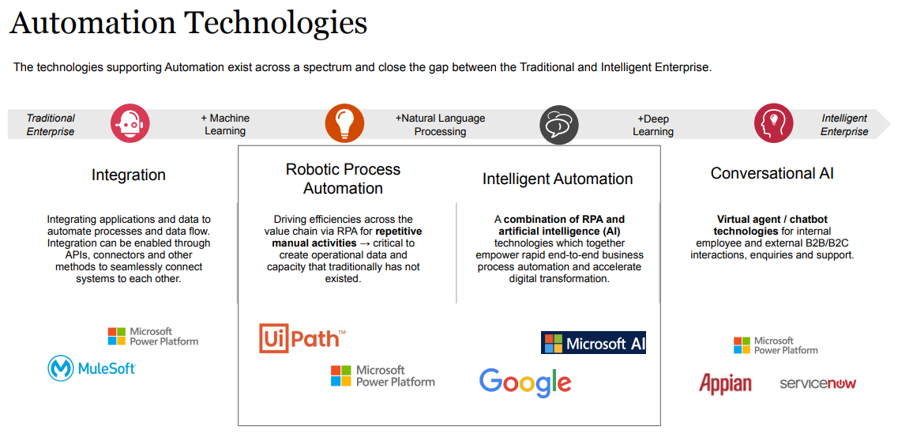

**Section 1: What is being assessed?**

Each individual programme listed below will be completing individual EqIAs detailing the impact on protective characteristics:

* Application and IT Infrastructure 2024-2027 Business Case
* Workforce unitisation
* Customer contact management
* Modern workplace transformation
* Culture transformation programme
* Localities programme
* Improving our use of data (linked to the HDRC)

This EqIA will not seek to replicate these, but will detail the impact of the proposal on internal (workforce) and external (customers and stakeholders) with protected characteristics

|  |  |
| --- | --- |
| **Protected Characteristics:** | **Impact**  **Y/N** |
| **Age** | **N** |
| **Disability** | **Y** |
| **Gender reassignment** | **N** |
| **Race** | **N** |
| **Religion/Belief** | **N** |
| **Pregnancy and maternity** | **N** |
| **Sexual Orientation** | **N** |
| **Sex** | **N** |
| **Marriage and civil partnership** | **N** |
| **Additional Consideration:** |  |
| **Low income/low wage** | **Y** |
| **Care Leavers** | **N** |

**Stage 2: Full Equality Impact Assessment:**

* 1. **Will this proposal advance equality of opportunity for people who share a protected characteristic and/or foster good relations between people who share a protected characteristic and those that do not? If yes, please explain further. Please ensure you have understood the meaning of ‘equality of opportunity’ and ‘fostering of good relations’ and ‘protected characteristics’- before answering this part.**

Yes, digitally enabling a council and optimising efficiencies in internal processes can lead to several positive improvements in terms of equalities impacts for people with protected characteristics:

**Improved Accessibility**

* **For people with disabilities (physical, visual, or hearing impairments):** Digital platforms can be designed to be more inclusive by offering accessibility features like screen readers, voice commands, captions, and alternative text. This makes services more accessible to people who may struggle with traditional, in-person, or paper-based services.
* **For people with limited mobility:** Digital services reduce the need for physical visits, allowing people to access services from the comfort of their homes, which can be particularly beneficial for those with mobility impairments or chronic illnesses.

**Increased Flexibility in Service Delivery**

* **For carers or people with children:** Offering digital services means people can access them at times that suit their schedules. This can particularly benefit individuals with caregiving responsibilities or parents, who may struggle with fixed office hours.
* **For older people:** Training and easy-to-use interfaces can empower older adults to engage with digital services, offering independence and reducing reliance on physical visits.

**Elimination of Bias and Discrimination**

* **For all protected groups:** Digital processes can standardise the delivery of services, reducing the potential for unconscious bias or discrimination in decision-making. Automated processes are often more consistent and transparent than human-led ones, ensuring fairer outcomes.

**Wider Reach for Hard-to-Reach Groups**

* **For people in remote or underserved areas:** Digital services provide better access to people living in remote locations, ensuring that geographic barriers do not limit access to council services.
* **For non-native speakers or people with language barriers:** Digital platforms can include multilingual support or translation features, which can improve access to services for people whose first language is not English.
* **For ethnic minorities, women, and LGBTQ+ communities:** Digital transformation can give underrepresented or marginalised groups easier and safer ways to interact with the Council, participate in consultations, and access support. Online environments may feel more neutral or anonymous, encouraging participation from those who might otherwise feel marginalized in face-to-face interactions.

**Data-Driven Insights to Identify Inequalities**

* The use of digital systems allows the Council to collect and analyse data on service usage. This can help identify where certain groups (e.g., people with disabilities, ethnic minorities, or older people) may be under-served or facing barriers, leading to more targeted interventions and support.

**Cost Reduction for Low-Income Groups**

* **For people on low incomes:** The shift to digital can reduce costs related to transport or childcare, making it easier for low-income groups to access services without incurring additional financial burdens.
  1. **Will this proposal have a positive impact and help to eliminate discrimination and harassment against, or the victimisation of people who share a protected characteristic? If yes, please explain further.**

No

* 1. **Will this proposal potentially have a negative and/or disproportionate impact on people who share a protected characteristic? If yes, please explain further.**

The programme has a low level of potential impact on disability protected characteristics and low income/low wage.

* 1. **Please indicate the level of negative impact on each of the protected characteristics?**

(Please indicate high (H), medium (M), low (L), no effect (N) for each)

|  |  |
| --- | --- |
| **Protected Characteristics:** | **Impact**  **(H, M, L, N)** |
| **Age** | **N** |
| **Disability** | **L** |
| **Gender reassignment** | **N** |
| **Race** | **N** |
| **Religion/Belief** | **N** |
| **Pregnancy and maternity** | **N** |
| **Sexual Orientation** | **N** |
| **Sex** | **N** |
| **Marriage and civil partnership** | **N** |
| **Additional Consideration:** | **N** |
| **Low income/low wage** | **L** |
| **Care Leavers** | **N** |

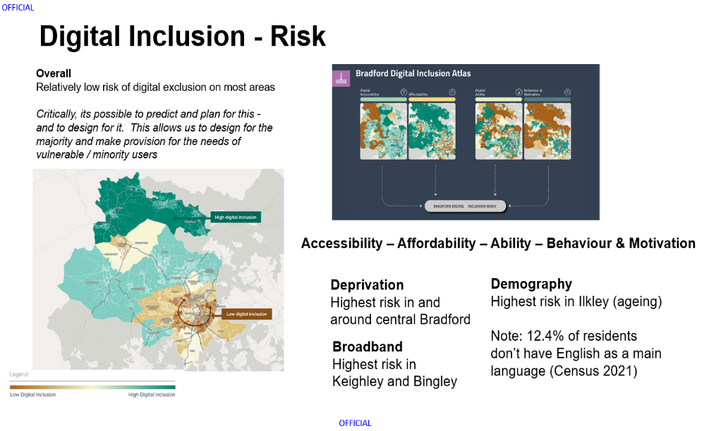

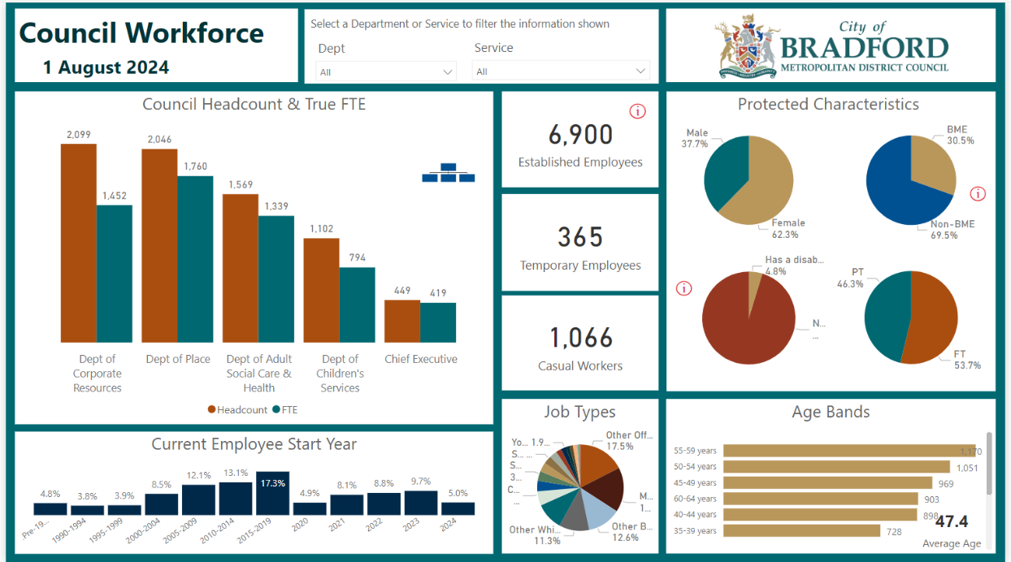

**2.5 How could the disproportionate negative impacts be mitigated or eliminated?**

There are specific actions in place to mitigate risk of disproportionate negative impact.

**Digital inclusion**

Digital inclusion refers to the equitable access to and effective use of digital technologies and services. It encompasses factors such as internet connectivity, availability of devices, digital skills, and digital literacy. A high level of digital inclusion ensures that all individuals can participate fully in the digital society, benefiting from the opportunities it offers.

**Mitigation:**

A formalised governance structure is in place (detailed above), with a dedicated digital inclusion board to ensure those who may be digitally excluded will have appropriate means to access Council services. Similarly, internal staff will be trained and reskilled to use systems and improve process functionalities within the council.

* Digital Skills Training: will be offered to improve digital literacy for groups that may struggle with technology, such as people with disabilities. Providing ongoing technical support will also help ensure these groups can navigate digital platforms confidently.
* A range of functional requirements will be included in the specifications of systems to ensure that we can best evaluate how they meet the needs of everyone, specifically in terms of staff groups with accessibility requirements for system/app used as part of their role, and for citizens to have a range of channel option to choose how to engage with the Council that best suits their needs that are accessible to them, this will continue to include face to face contact.

Any significant impact on workforce would be subject to staff consultation in accordance with Councils Managing Change Policy.

**Digital Inclusion Objective**

* **Promote Equitable Access to Digital Services**
* Monitor and address digital divides based on socioeconomic status, geography, age, disability, or other protected characteristics.
* **Enhance Digital Literacy**
* Develop and support programs to increase digital literacy and skills, particularly for groups at risk of digital exclusion (e.g., older adults, people with disabilities, low-income households).
* Provide accessible, tailored training to help people confidently engage with digital services, ensuring no one is left behind in the shift to digital.
* **Ensure Accessibility of Digital Platforms**
* Ensure that all council digital platforms comply with accessibility standards, ensuring they are usable for people with disabilities, older adults, and non-native speakers.
* Regularly review and improve user experience through inclusive design, with input from people with protected characteristics.
* **Maintain Multi-Channel Service Delivery**
* Ensure that non-digital alternatives (e.g., telephone or face-to-face services) remain available for those who cannot or prefer not to access services online.
* Promote a hybrid service model, combining digital and non-digital channels to meet diverse needs.
* **Foster Collaboration and Engagement with Communities**
* Engage with local communities, advocacy groups, and service users to co-design digital services that meet the needs of all, including underrepresented or marginalized groups.
* Establish regular feedback mechanisms to understand the needs, experiences, and challenges faced by different communities when accessing digital services.
* **Promote Data Privacy and Security for Vulnerable Groups**
* Ensure that digital platforms are secure and protect personal data, particularly for individuals who may have heightened concerns (e.g., survivors of domestic abuse, LGBTQ+ individuals).
* Build trust by promoting transparent practices around data use, ensuring privacy is respected in all digital services.
* **Monitor and Evaluate Digital Inclusion Progress**
* Establish metrics to assess digital inclusion, tracking progress in reducing the digital divide and increasing digital engagement across all demographics.
* Conduct regular equality impact assessments to ensure that digital services do not disproportionately disadvantage any group and adjust strategies accordingly.
* **Address Barriers to Digital Inclusion**
* Identify and address specific barriers faced by protected groups, such as language, cultural sensitivities, financial constraints, or limited technical skills.
* Offer targeted support to overcome these barriers, such as subsidized internet access, assistive technologies, or multilingual resources.
* **Support Staff Training and Capacity Building**
* Ensure council staff are trained to support residents in accessing digital services, including training on equality, diversity, and digital inclusion principles.
* Equip frontline staff with the knowledge and tools to assist people who may face barriers to digital access, offering personalized support where necessary.
* **Develop Strategic Partnerships**
* Partner with technology providers, educational institutions, non-profits, and community organizations to expand the reach of digital inclusion initiatives and secure additional resources for vulnerable groups.
* Work collaboratively with regional and national initiatives aimed at closing the digital divide and improving inclusion.

**Digital Inclusion Programme Board – Terms of Reference summary**

* The primary purpose of the Digital Inclusion Board will be to provide strategic oversight, supporting collaborative working across the district and beyond; monitoring progress against development and delivery of the programme, including benefits realisation and finance.
* The board will ensure that matters which might prevent the success of the programme are addressed swiftly. Issues requiring escalation to the Board will be raised via the Digital Inclusion Programme Manager
* The Digital Inclusion Board members will also act as programme champions who are committed to the programme objectives, the proposed outcomes and the approach to delivery. This will improve visibility of the programme at a range of senior leadership sessions in organisations across the district

**Accountability & Management**

* The Digital Inclusion Board will be chaired by the sponsor, Marium Haque Children’s Services Director.
* The Digital Inclusion Working Group will be accountable to the Digital Inclusion Board and will be chaired by the Digital Inclusion Programme Manager
* The day-to-day work and management of the Digital Inclusion Working Group will be led by the Digital Inclusion Programme Manager
* The Digital Inclusion Working Group will report to the Digital Inclusion Board monthly in the first instance, moving to bi-monthly, to provide updates on progress and activity. The Digital Inclusion Programme Manager will prepare and present this report
* The Digital Inclusion Board will approve progress updates to the Health and Wellbeing Board on a minimum quarterly basis, or as directed by the Health and Wellbeing Board. The Digital Inclusion Programme Manager will prepare and present this report

**Section 3: Dependencies from other proposals**

**3.1 Please consider which other services would need to know about your proposal and the impacts you have identified. Identify below which services you have consulted, and any consequent additional equality impacts that have been identified.**

The programme will be cross cutting through the council and regular communications will be undertaken internally and externally through the council communication team. During the Programme initiation a communication strategy will be undertaken to identify all stakeholders who will be involved.

As part of the programme all training which will be arranged will consider protected characteristics. All training will ensure that where possible it is not all via MS Teams, user guides will also be written and where appropriate super users for the system (regardless of their protected characteristic) will be available to support colleagues and users.

**Section 4: What evidence have you used?**

**4.1 What evidence do you hold to back up this assessment?**

The Programme have reviewed Bradford’s rich demographic dataset to understanding resident characteristics, trends, and preferences to ensure these can be taken into consideration in future decisions around customer contact solutions (feeding into the Council owned business case).

For workforce data, the council utilises[**BI Power dashboard**](https://powerbiinternal.bradford.gov.uk/reports/powerbi/HR/Live%20Workforce%20Dashboard?rs:embed=true)reporting capabilities to ensure it has continual reporting on workforce data on those with protected characteristics.

As part of the programme, we will be working closely with the communications team to identify forums for the organisation to be involved in where we can consult. This engagement will continue through the current Business Case stage and beyond into delivery.

**Section 5: Consultation Feedback**

Each individual programmes listed below will be completing individual EqIAs detailing the impact on protective characteristics and the consultation plan with staff and residents. These programmes are:

* Application and IT Infrastructure 2024-2027 Business Case
* Workforce unitisation
* Customer contact management
* Modern workplace transformation
* Culture transformation programme
* Localities programme
* Improving our use of data (linked to the HDRC)

This EqIAs will not seek to replicate these, but will ensure compliance detailed in section 2, question 2.5, on how potential disproportionate negative impacts will be mitigated via robust monitoring in governance structures.

**Feedback from the Council budget proposals 2025-26 engagement and consultation**

Consider access needs of older people, disabled people, those on low income or whose first language isn’t English as may not be able to access via digital or in the same way as others. Impact assessment needed on deaf community.

**Departmental response to the feedback on the current consultation – include any changes made to the proposal as a result of the feedback.**

Thank you for your feedback. We acknowledge the importance of considering the access needs of older people, disabled individuals, those on low income, and those whose first language isn’t English.

We believe this is covered in section 2.5 of the EQIA, where we discuss the positive improvements, digital enabling can bring regarding equality impact. To ensure inclusivity, we are committed to engaging with the Digital Inclusion Programme Manager and the Training Workforce Development team to ensure upskilling is aligned with the diverse needs of our community.

Additionally, we will explore further measures to support those who may face barriers to accessing digital tools, ensuring that our approach is comprehensive and equitable.

To ensure inclusivity for the deaf community when implementing digital tools like automation and AI, we will consult with the community to understand their specific access needs. I recently attended an EDI in AI transformation presentation to learn how we can ensure equality, diversity, and inclusivity in AI transformation within councils, demonstrating our commitment to considering everyone's needs. Additionally, we will review relevant documents and guidance, such as the Public Sector Equality Duty and data protection guidelines such as[**The Public Sector Equality Duty and data protection | EHRC**](https://www.equalityhumanrights.com/guidance/public-sector-equality-duty-and-data-protection), to identify and implement appropriate mitigations.

Digital tools like voice automation, AI, and automation can significantly impact the deaf community. Voice-activated systems and automated voice messages can be inaccessible to individuals who are deaf or hard of hearing, creating barriers to essential services and information.

To combat these challenges, we can:-

1. Consult with the Deaf Community: Engage with the community to understand their specific needs and preferences.
2. Provide Alternative Communication Methods: Offer text-based alternatives such as real-time captioning, text-to-speech, and speech-to-text services.
3. Ensure Accessible Design: Incorporate features like visual alerts and easy-to-navigate interfaces from the outset.

On the positive side, AI-powered solutions can enhance communication for the deaf community. Technologies such as real-time captioning, speech-to-text, and text-to-speech services can bridge communication gaps and make interactions more inclusive. These tools can be used in various settings, including phone calls, video conferences, and in-person conversation.

Although this project does not currently include voice automation, if the need arises, we will prioritise accessibility by implementing these strategies to mitigate any negative effects on the deaf community and ensure our digital tools are inclusive for everyone.

**Return to contents page**

**Return to contents page**

Equality Impact Assessment Form

|  |  |  |  |
| --- | --- | --- | --- |
| **Department** | Adult Social Care | **Version no** | 0.1 |
| **Assessed by** | Imran Rathore | **Date created** | 15.07.24 |
| **Approved by** | Rachael Meadows-Hambleton | **Date approved** | 08.08.24 |
| **Updated by** |  | **Date updated** |  |
| **Final approval** | Rachael Meadows-Hambleton | **Date signed off** | 15.08.24 |

The Equality Act 2010 requires the Council to have due regard to the need to

* eliminate unlawful discrimination, harassment and victimisation;
* advance equality of opportunity between different groups; and
* foster good relations between different groups

Section 1: What is being assessed?

**1.1 Name of the proposal to be assessed.**

Safe and Sound improvement programme – this includes specific actions required to

* *Meet the requirements of the Digital Switchover*
* *Increase the awareness and promote the service, both internally across the Council and externally with partners and residents to increase uptake*
* *Implement plans to maintain a sustainable service through the implementation of a varied charging model.*

**1.2 Describe the proposal under assessment and what change it would result in if implemented.**

**1.2.1 SERVICE OVERVIEW:**

Safe and Sound is an existing service within Bradford Council, Adult Social Care Service. It is a combination of what was historically known as Careline and Telecare. It is a person-centered service supporting people to stay safe and independent in their own home.

The Safe and Sound Service operates in partnership with other health and social care organisations and emergency services, such as, West Yorkshire Ambulance Service and the Yorkshire Fire and Rescue Service, delivering a 24/7 emergency response to people’s homes.

Safe and Sound uses a variety of technology and support systems to help people of all ages to live safely and independently at home. The Service offers help 24 hours a day 365 days a year, giving people independence and freedom in their own home, whilst safe in the knowledge that if there is an accident or if you have a fall, help is available in the form of an emergency response.

Referrals are received from a range of sources and following the referral, the service undertakes an assessment with the person (and or their carers), to ensure the appropriate safety equipment and technology is issued to support independent living.

**1.2.2 CHANGE RATIONALE:**

In Bradford the population for 65-90+ is forecast to increase from 86,413 to 103,219 by 2033. The breakdown of this across 65+ age group is outlined below:

|  |  |  |  |  |  |  |  |  |  |  |  |  |
| --- | --- | --- | --- | --- | --- | --- | --- | --- | --- | --- | --- | --- |
| **AGE GROUP** | **2023** | **2024** | **2025** | **2026** | **2027** | **2028** | **2029** | **2030** | **2031** | **2032** | **2033** | **% Change** |
| 65-69 | 25,303 | 25,698 | 26,411 | 26,862 | 27,337 | 27,614 | 28,163 | 28,459 | 28,641 | 28,901 | 29,087 | **14.96%** |
| 70-74 | 21,289 | 21,393 | 21,414 | 21,886 | 22,291 | 22,785 | 23,167 | 23,834 | 24,277 | 24,742 | 25,033 | **17.59%** |
| 75-79 | 17,520 | 18,164 | 18,885 | 19,276 | 18,695 | 18,494 | 18,600 | 18,637 | 19,061 | 19,445 | 19,912 | **13.66%** |
| 80-84 | 10,923 | 11,201 | 11,294 | 11,704 | 13,132 | 14,074 | 14,600 | 15,161 | 15,451 | 15,027 | 14,904 | **36.44%** |
| 85-89 | 7,381 | 7,355 | 7,398 | 7,280 | 7,155 | 7,216 | 7,449 | 7,566 | 7,865 | 8,897 | 9,568 | **29.63%** |
| 90+ | 3,999 | 4,081 | 4,169 | 4,236 | 4,369 | 4,474 | 4,513 | 4,591 | 4,569 | 4,595 | 4,715 | **17.92%** |
| **Total** | 86,413 | 87,890 | 89,572 | 91,243 | 92,978 | 94,657 | 96,493 | 98,248 | 99,863 | 101,606 | 103,219 | 19.44% |
| Source: Office for National Statistics 2023 | | | | | | | | | | | | |

Similarly, it is projected that people with learning disabilities will increase from 1,872 to 2,237 between 2025 to 2035, representing a 19.5% rise. Comparable accurate ONS based data for people with mental health and physical disabilities is unavailable at this time.

Helping people to feel safe in their home, knowing that they are monitored in the event of something going wrong, especially if living alone, in a safe and cost-efficient manner is an important priority for the Council, and as such ensuring that we have a sustainable Safe and Sound service to meet people's needs is a key priority for Adult Social Care.

**1.2.3 IMPROVEMENT WORKSTREAMS:**

**1.2.3.1 Digital Switch Over:**

Work is underway within the service to ensure that we can maintain service delivery as the analogue network is switched off and we move to a digital network – this is a national change workstream led by the major network providers. As part of our response to this change process, we have procured and are in the process of implementing a new Digital Alarm Receiving Centre (ARC) which will allow digital equipment within people’s homes to connect to the Digital ARC via a broadband network. Similarly, work is also being undertaken to procure digital equipment which will replace the existing analogue kit in people’s homes. PAG funding was used to finance this activity.

**1.2.3.2 Technology Enabled Care (TEC):**

The shift to the digital ARC opens up the possibility of implementing new and innovative technologies to support people in a more proactive and creative ways – ranging from: remote monitoring sensors, addressing social isolation, minimising falls prevention, avoiding Unitary Tract Infections through Artificial Intelligence based behaviour learning, and supporting people to live with Dementia e.g. providing reminders to people about taking their medication, food, and fluids etc.

This means repositioning and redesigning the Safe and Sound Service offer, away from a basic telecare offer to a more rounded Technology Enable Care Offer which provides a holistic support package that meets a person’s needs on a day-to-day basis. To support this change, we have worked collaboratively with both the Safe and Sound Service and Operational Services to promote the benefits of the TEC offer, and how it can support a person’s needs. This work includes:

* *Raising awareness of the service offer with Adult Social care staff and external key stakeholders including partners within the Health and Social Care partnership.*
* *Attending staff roadshows and running in-person and virtual staff information workshops.*
* *Developing the internal and external information and advice offer. This includes plans to refresh our TEC website, council website and exploring the use of online newsletters and social media once the new digital ARC is established.*
* *Reviewing the equipment options compatible with the new ARC to enhance service options and working collaboratively with other regional councils to review and evaluate new TEC into the market.*
* *Evaluation of prevention focused TEC solutions to demonstrate where they add value by maintaining independence and delaying the need for statutory care provision.*
* *Streamlining the TEC referral pathways to increase efficiency and speed of access.*
* *Working with Bradford University to develop a TEC House and TEC Website, and presenting this work as part of a Local Government Association (LGA) series of Webinars titled “What Good Looks Like Webinar Two: Improving Care & Empower People”*
* *Providing accompanied visits to the TEC House to raise awareness and provide ‘hands on learning’.*
* *Trialling working with university students in the facility of health to raise awareness of available TEC in the community and discussing joint training options for staff and students.*
* *Developing induction TEC training for new staff members with a view to make this statutory for all staff annually.*
* *Engagement and consultation with current services users and family to understand the lived experience of using the Safe and Sound service, the impact on both users and the people who care for them and exploring where people feel there are gaps in service provision and where improvements could be made.*

**1.2.3.3 Charging Model**

**Current approach:**

We currently charge a flat rate for the Safe and Sound offer which is £3.30 per week (excluding VAT). This is applied to anyone currently receiving Safe and Sound support and is not linked to the type of support provided.

The contribution charge that we make includes a rental charge for the equipment, a monitoring service and emergency response when necessary. The equipment provided and installed remains a Bradford Council Asset and is deemed on long term loan until it is no longer required. There are no additional charges for any supplementary Telecare sensors a person needs to stay safe. E.g. Fall detectors. We currently offer the first six weeks free of charge to enable the person and their carers to test out the suitability of the service and to ensure it is making a positive impact on their wellbeing.

**Change proposal:**

To ensure that the service is sustainable, reliable, cost effective and meets the needs of the people we support, we have undertaken a detailed appraisal of our current funding model. This has included benchmarking our approach with other Local Authorities within Yorkshire, which also include our statistical neighbours. Key point to note is that standard charge applied by the other Local Authorities is higher than the current charge in Bradford. The table below provides a breakdown of the new funding model:

| **Subsidised Model (benchmarked against Leeds) - subject to a 4.5-8.5% uplift from 1st April 2025)** | | | | |
| --- | --- | --- | --- | --- |
| **Package Name** | **1 Basic Package – Standalone** | **2 Basic Package - Monitored** | **3 Home Safety Package** | **4 Falls Package** |
| Cost without mobile response (MR) | **£2.31** | **£4.62** | **£6.00** | **£6.46** |
| Monthly Cost | £10.00 | £20.00 | £26.00 | £28.00 |
| Cost with mobile response (MR) | N/A | **£8.62** | **£10.00** | **£10.46** |
| Monthly Cost with MR | N/A | £37.35 | £43.33 | £45.33 |
| Total costs - non equipment |  |  |  |  |
| Total costs - non equipment | £2,231,219 |  |  |  |
| Current self-funded budget | £697,100 | Modelling is based upon mapping existing users across to the new packages, based upon current service in place, to improve accuracy of forecasts | | |
| Incremental income forecast / budget saving for council against current investment | £926,914 |
| Income adjusted for Disability Related Expenditure (DRE) @ 10% | £834,223 |
| **Gap not self-funded** | **£699,895** |

**1.3 Stage 1 Assessment:**

|  |  |
| --- | --- |
| **Protected Characteristics:** | **Impact**  Y/N |
| Age | Y |
| Disability | Y |
| Gender reassignment | Y |
| Race | Y |
| Religion/Belief | Y |
| Pregnancy and maternity | Y |
| Sexual Orientation | Y |
| Sex | Y |
| Marriage and civil partnership | Y |
| **Additional Consideration:** |  |
| Low income/low wage | Y |
| Care Leavers | Y |

Section 2: What the impact of the proposal is likely to be

* 1. **Will this proposal advance equality of opportunity for people who share a protected characteristic and/or foster good relations between people who share a protected characteristic and those that do not? If yes, please explain further.**

No

* 1. **Will this proposal have a positive impact and help to eliminate discrimination and harassment against, or the victimisation of people who share a protected characteristic? If yes, please explain further.**

The enhanced support offer will enable people who share a protected characteristic to retain their independence within their own home (or supported living) while enabling them to continue to actively engage in their wider community. The approach we are taking should help reduce the potential for such exclusion and isolation.

In addition the new system will enable better collection of data on service users which will ensure that there is a better understanding on who is using the service including from groups with protected characteristics.

* 1. **Will this proposal potentially have a negative or disproportionate impact on people who share a protected characteristic? If yes, please explain further.**

Yes, the increase in charges may have an impact on people currently receiving a service as some will see an increase in the cost of their support package. However, this impact is not anticipated to disproportionately impact those with protected characteristics.

The proposed consultation exercise will collect more detailed information on identifying any impacts, with consideration given to the needs of users whose first language is not English (race), those that are not digitally connected, low income, accessibility and disability.

**2.4 Please indicate the level of negative impact on each of the protected characteristics?**

(Please indicate high (H), medium (M), low (L), no effect (N) for each)*.*

As this is an internal replacement of case management software, we do not anticipate any direct impact on staff.

|  |  |
| --- | --- |
| **Protected Characteristics:** | **Impact**  (H, M, L, N) |
| Age | H |
| Disability | H |
| Gender reassignment | M |
| Race | M |
| Religion/Belief | M |
| Pregnancy and maternity | M |
| Sexual Orientation | M |
| Sex | M |
| Marriage and civil partnership | M |
| **Additional Consideration:** |  |
| Low income/low wage | M |
| Care Leavers | N |

**Implication for existing service users:**

**Breakdown by “Ethnicity”:**

This represents an overview of existing persons by ethnicity if transposed across to the “preferred to-be model” based upon their current package. As a proportion, majority Asian are in receipt of the free standalone package, which would form part of the lowest level charge in the new proposed model, in terms of volumes this is low and represents a minimal risk. Whereas for “white” ethnicity the majority are evenly divided between basic and enhanced packages.

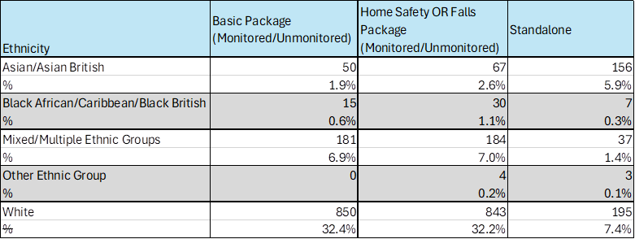

**Overall ethnicity of existing people using the service.**

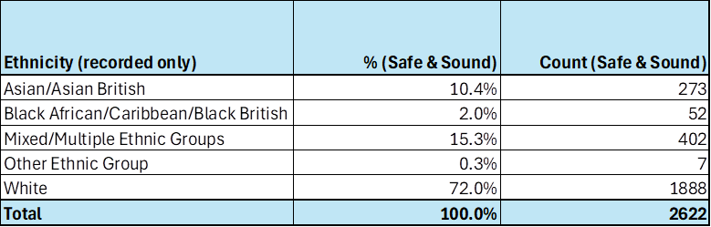

**A representation of ethnicity by age profile, the most vulnerable of whom fall within the 65+ category.**

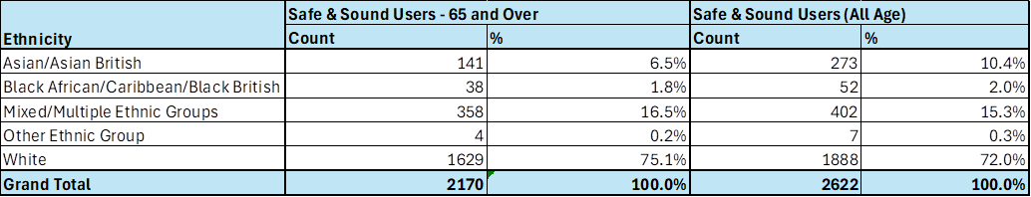

**Cost Profile Analysis**

This details the users mapped across to the new packages and a breakdown of package costs. The majority of existing users, representing 45%, if transferred across to the new charges would experience an uplift starting at £4.62 compared to the current £3.30. This reduces the impact of the change alongside with the recommended phased implementation.

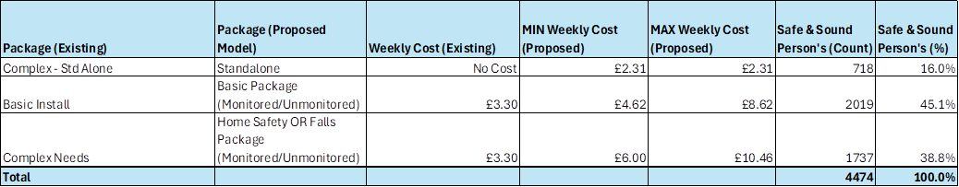

**Gender**

Over 60% of existing people who use the safe and sound service are female. Of those over 80% are presently paying a contribution to the service. Therefore, the impact of the change is expected to be minimal compared to if the majority were receiving the standalone service.

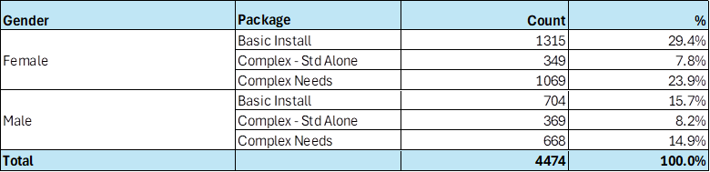

As part of the implementation of the new Digital ARC and through the consultation process we are aiming to capture additional details covering protected characteristics, this will help our understanding of the needs of the current service users.

**2.5 How could the disproportionate negative impacts be mitigated or eliminated?**

(Note: Legislation and best practice require mitigations to be considered, but need only be put in place if it is possible.)

We are proposing that subject to Executive approval the new charges are implemented from 1st April 2025 for all new service users. At this stage, we are seeking Executives approval to undertake a formal consultation exercise with key stakeholders and bring back the findings from this exercise to the Executive for their consideration. Following approval from Executive to go out to consultation, we will write to all existing service users who are receiving Safe and Sound service to inform them of the proposed changes and the implications for them, and to provide them with options for sharing their feedback.

**Section 3: Dependencies from other proposals**

**3.1** **Please consider which other services would need to know about your proposal and the impacts you have identified. Identify below which services you have consulted, and any consequent additional equality impacts that have been identified.**

As this service is operated in conjunction with other organisations, the proposal is planned to be consulted with our partners which include, health and social care organisations, West Yorkshire Ambulance Service and the Yorkshire Fire and Rescue Service.

Section 4: What evidence you have used?

**4.1 What evidence do you hold to back up this assessment?**

From the data available via the following, we know that demand for ASC services will continue to increase in the coming years, so having access to robust and Care Act compliant case management system is a critical component for operational service delivery.

* + Poppi and Pansi data
  + ONS population projections.
  + Carers feedback
  + Feedback from people who receive support or their carers/advocates.

The evidence on the usage by groups with protected characteristics is included in the earlier sections of the EQIA.

**4.2 Do you need further evidence?**

There may be further evidence from the consultation which will be considered once this is received.

Section 5: Consultation Feedback

**5.1 Results from any previous consultations prior to the proposal development.**

The plan is to seek approval at Council Executive on the 3 September to go out to formally consult on the proposals outlined in this paper for a period of 3 months. This will cover not only people who use our services, but also families and carers, along with partners.

**5.2 The departmental feedback you provided on the previous consultation (as at 5.1).**

We undertake regular surveys with current service users who have provided positive feedback on their experience of using the service. Key messages include:

* 80.2% were either extremely or very satisfied with the equipment they received.
* 80.2% said that the TEC helped them have as much control over their daily life as they wanted.
* 80.2% said that the TEC helped them have as much control over their daily life as they wanted.
* 80.2% said that the TEC helped them have as much control over their daily life as they wanted.

**5.3 Feedback from current consultation following the proposal development (e.g. following approval by Executive for budget consultation).**

The consultation has started but not yet concluded.

**5.4** **Your departmental response to the feedback on the current consultation (as at 5.3) – include any changes made to the proposal** **as a result of the feedback.**

This will be fed back when the consultation is completed**.**

[Report of the Strategic Director for Adult Social Care and Health to the meeting of Executive Tuesday 3 September 2024](https://bradford.moderngov.co.uk/documents/s48043/Doc%20J.pdf)

**Resolved –**

**That the Executive:**

**(1)           Recognised the developments in the Safe and Sound Service to implement a Technology Enabled Care offer.**

**(2)           Agreed for a formal consultation to be undertaken with current service users and stakeholders on the proposal to change the charging model.**

**(3)           Agreed for the Strategic Director for Adult Social Care and Health to bring a report back to the Executive setting out the feedback from the consultation and recommendations on the proposed way forward.**

***To be actioned by: Strategic Director for Adult Social Care***

**Return to contents page**

**Review of the Capital Programme (Revenue savings £2.600m)**

There is no overarching EQIA

**Budget consultation feedback**

Do community impact assessments on assets that will potentially be disposed.

VCSE request that Asset Management consult them about potential sale of assets.

**Facilities management response at 27 January 2025**

The Council adheres to its Disposals Policy in relation to the disposal of Council owned assets which generate capital receipts and form an integral part of the Councils Medium Term Financial Strategy.

The Council does not undertake Community Impact Assessments on Disposals as the assets being sold are either investment properties, surplus land holdings or other surplus assets no longer required.

In all cases the Council is under a legal obligation to achieve best consideration in terms of disposal receipts and this is achieved by sale on the open market with appropriate marketing. If there are special purchaser considerations then specialist valuation advice is sought.  The Council also operates a Community Asset Transfer scheme.

This is a link to the Council’s Disposals policy:

<https://www.bradford.gov.uk/media/6933/disposal-policy-jan-2019.pdf>

**Return to contents page**